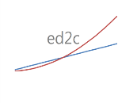
Engineering Data Corporation 502-412-4000
Box 5636 888-678-0683
Louisville KY 40255-0636 http://ed2c.com

December 10, 2015

Confidentiality Agreement and Notice of Privacy Practices

{Agency Name}
{Agency Address}
{Agency City State Zip}

This agreement is intended to document our compliance with your organization’s privacy requirements and with the terms of all applicable federal and state statutes that pertain to the safeguarding of sensitive personal information, including the Health Insurance Portability and Accountability Act of 1996. All employees and subcontractors of Engineering Data Design Corporation (ED2C) are required to sign a confidentiality statement to indicate their acceptance of this agreement.

ED2C acknowledges that, during the course of our work with your agency, we may be entrusted with confidential and/or proprietary information, including the personal records of your clients. ED2C, its employees, and its subcontractors agree that we will not use such confidential information for any purpose other than for the performance of services for your agency.

ED2C agrees that we will not disclose any personal or confidential information of any kind to any person or agency without your knowledge and without your written permission, unless we are otherwise required to do so by law. ED2C, its employees and its subcontractors will use and maintain reasonable security measures to protect your agency’s confidential information. All such information, whether in printed or digital form, shall be destroyed at your request or when it is no longer needed for the performance of services for your agency.

By using ED2C data systems, you acknowledge that your agency personnel will follow industry best practices to safeguard the sensitive personal information of your clients. If you use ED2C systems to store your client data in an internet-accessible database, you acknowledge that you have obtained the informed, written consent of all clients whose personal information is accessible via the internet.

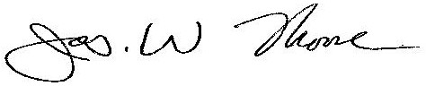
Engineering Data Design Corporation {Agency Name}
___________________________ ___________________________
James W. Moore {Authorized Agency Representative}
President ED2C

